Supplemental Data
Supplemental table 1. Effect of adjustment for patient characteristics, socioeconomic determinants, and environmental air quality, on the association of a 0.01 mg/L higher 90th percentile lead level on hemoglobin concentrations and Erythropoietin Stimulating Agent use.
Supplemental figure 1. Flow chart outlining merge of Safe Drinking Water Information System and United States Renal Data System to create complete dataset of 597,968 unique ESKD patients.
Supplemental figure 2. Adjusted difference in hemoglobin concentration during the first month of dialysis, according to the 90thpercentile drinking water lead concentration in patient’s city of primary residence. To account for the effect of ESA treatment, corrected hemoglobin was derived by subtracting 2 g/dL from observed hemoglobin concentration among ESA users during the first month of dialysis. Adjusted for age, sex, race, history of diabetes, congestive heart failure, hypertension, cancer, tobacco use, body mass index, estimated glomerular function, insurance status, employment, year of dialysis initiation, and county air pollution. Dashed lines reflect 95% confidence interval. The figure excludes patients in cities with reported lead concentration ≥0.03 mg/L.
Supplemental figure 3. Adjusted difference in ESA use during the first month of dialysis, according to the 90th percentile drinking water lead concentration in patient’s city of primary residence. Adjusted for age, sex, race, history of diabetes, congestive heart failure, hypertension, cancer, tobacco use, body mass index, estimated glomerular function, insurance status, employment, year of dialysis initiation, and county air pollution. The figure excludes patients in cities with lead concentrations ≥0.03 mg/L.

 | Adjusted difference in hemoglobin concentration and erythropoietin-stimulating agent (ESA) use per 0.01 mg/L higher 90th percentile lead concentration in community water
 | Pre-ESKD |  |  | First month of ESKD
 | Hemoglobin | Corrected hemoglobin | ESA use | Hemoglobin | Corrected hemoglobin | ESA use
Model 1 | -0.024  (-0.031, -0.017) | -0.035  (-0.044, -0.026) | 0.47%  (0.26, 0.68) | -0.053  (-0.063, -0.042) | -0.054  (-0.068, -0.040) | 0.36%  (-0.02, 0.74)
Model 2 | -0.019  (-0.025, -0.012) | -0.031  (-0.040, -0.022) | 0.46%  (0.25, 0.66) | -0.047  (-0.058, -0.037) | -0.047  (-0.061, -0.034) | 0.30%  (-0.08, 0.67)
Model 3 | -0.019  (-0.026, -0.012) | -0.031  (-0.040, -0.022) | 0.44%  (0.23, 0.65) | -0.047  (-0.058, -0.037) | -0.047  (-0.061, -0.034) | 0.31%  (-0.07, 0.68)
Model 4 | -0.018  (-0.025, -0.011) | -0.030  (-0.038, -0.021) | 0.42%  (0.21, 0.62) | -0.046  (-0.056, -0.035) | -0.046  (-0.059, -0.032) | 0.27%  (-0.10, 0.64)

Supplemental table 1. Effect of adjustment for patient characteristics, socioeconomic determinants, and environmental air quality, on the association of a 0.01 mg/L higher 90th percentile lead level on hemoglobin concentrations and Erythropoietin Stimulating Agent use.
Model 1 – adjusted for year of ESKD onset.
Model 2- adjusted for Model 1 variables and the following patient characteristics - age, sex and race, history of diabetes, congestive heart failure, hypertension, cancer, tobacco use, body mass index, and estimated glomerular function.
Model 3- adjusted for model 2 variables and patients employment and health insurance status at time of ESKD onset.
Model 4 – adjusted for model 3 variables and county level estimates of pollution.

Incident ESRD from 1/1/2005 to 12/31/2017
N=1,513,036
Safe Drinking Water
Information System
United States
Renal Data System
- Missing residence (n=23,301)
597,968 incident ESRD living in 9,566 cities served by 21,113 water systems
740,380 incident ESRD in cities with reported community water lead levels
- Missing preESKD hemoglobin (n=67,321)
- Missing preESKD ESA use (n=197,890)
- Missing additional preESKD data (n=74,980)
49,529 community water systems
30,759 report geographic service to 14,429 cities and 201,023 lead measurements
Supplemental figure 1. Flow chart outlining merge of data sources to generate complete dataset.

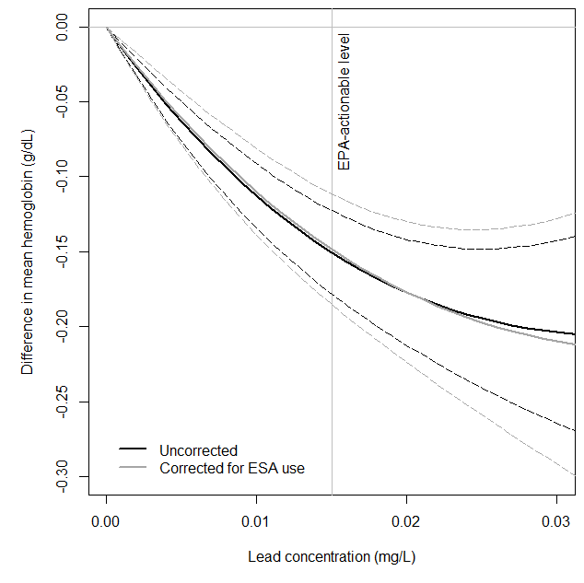
Supplemental figure 2. Adjusted difference in hemoglobin concentration during the first month of dialysis, according to the 90th percentile drinking water lead concentration in patient’s city of primary residence.
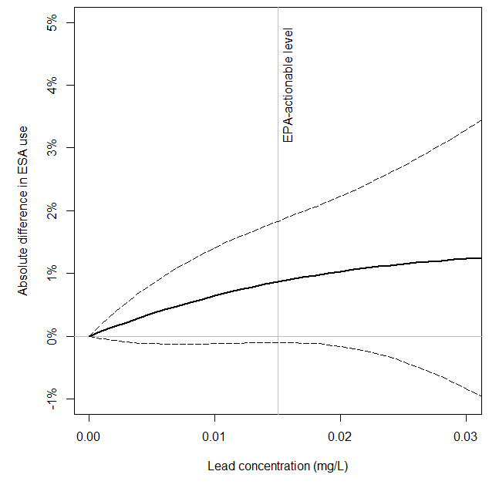
Supplemental figure 3. Adjusted difference in ESA use during the first month of dialysis, according to the 90th percentile drinking water lead concentration in patient’s city of primary residence.

