Supplementary Material

Supplementary Material Table of Contents
Supplemental Methods
Definitions of comorbid disease
Laboratory analyses
Supplemental Tables
Supplemental Table 1: Laboratory Parameters at Baseline
Supplemental Table 2: Baseline immunosuppressant medication
Supplemental Table 3: Humoral response in Covid-19-naïve patients: proportion of patients with titer above threshold
Supplemental Table 4: Cellular response (Antigen 1)
Supplemental Table 5: Characteristics of patients with adequate and impaired response
Supplemental Table 6: Multivariate analysis of factors associated with combined impaired humoral and cellular response at 8/9 weeks
Supplemental Table 7: Immune response at 8/9 weeks in Covid-19-experienced dialysis patients according to disease severity

Supplemental Figures
Supplemental Figure 1: Study flow chart
Supplemental Figure 2: Immune response by age category

Supplemental Methods

Definitions of comorbid disease
Coronary artery disease was defined as acute coronary syndrome or symptom-driven revascularization by percutaneous coronary intervention or coronary artery bypass grafting.
Heart failure was defined as left ventricular ejection fraction <45% or an unscheduled hospital admission for heart failure, characterized by typical signs and symptoms and diagnostic testing consistent with a diagnosis of heart failure, including elevated natriuretic peptides, radiological evidence of congestion or echocardiographic evidence of elevated filling pressures.
Cerebrovascular disease was defined as stroke (sudden onset of a focal neurological deficit consistent with the territory of a major cerebral artery) or carotid artery revascularization.
Peripheral vascular disease was defined as clinical evidence of limb ischemia due to atherosclerotic vascular disease requiring revascularization or amputation.
Abdominal vascular disease was defined as revascularization for or evidence of bowel ischemia, or repair or presence of an aortic aneurysm >5.5 cm.
Diabetes was defined as a hemoglobin A1c level of ≥6.5% and/or the use of oral antidiabetic drugs and/or insulin.
Chronic obstructive pulmonary disease was defined as presence of airflow obstruction caused by chronic bronchitis or emphysema and at least GOLD stage I.
Liver disease was defined as a Child-Pugh score of at least Class A.
Immunodeficiency was defined as solid organ transplantation with current use of immunosuppressive drugs, allogeneic stem cell transplantation, HIV infection with CD4 <200/µL, primary immunodeficiency or use of immunosuppressive therapy or chemotherapy for other reasons.
Malignancy was defined as solid or hematologic malignancy active or requiring therapy (surgery, radiotherapy or chemotherapy) within the past 5 years. Hormonal therapy alone without signs of active disease and basocellular epitheliomas of the skin were not taken into consideration.

Laboratory analyses
Serum albumin was measured in all participating centers with the bromocresol green (BCG) colorimetric assay (Roche Diagnostics, Mannheim, Germany).

Supplemental Tables

Supplemental Table 1: Laboratory Parameters at Baseline
Parameter | All hemodialysis  (n=543) | BNT162b2 recipients (n=322) | mRNA-1273 recipients (n=221) | **P
Hemoglobin, g/dL  Ferritin, ng/mL  Transferrin saturation, % | 11.2 (10.5-11.9)  387 (247-580)  23 (18-29) | 11.2 (10.4-11.9)  387 (226-559)  23 (17-28) | 11.2 (10.5-11.8)  387 (256-628)  24 (19-30) | 0.945  0.285  0.054
C3, g/L  C4, g/L  Leucocyte count, n/µL  Lymphocyte count, n/µL  Immunoglobulin G, g/L  Immunoglobulin M, g/L  Immunoglobulin A, g/L  Extra fraction, % (no.) | 1.01 (0.87-1.13)  0.25 (0.20-0.30)  6160 (4848-7900)  1080 (768-1403)  9.2 (7.5-11)  0.59 (0.36-0.89)  2.1 (1.5-2.9)  14 (73) | 1.04 (0.93-1.16)  0.24 (0.20-0.30)  6400 (5000-8000)  1000 (700-1385)  9.4 (7.6-12)  0.60 (0.39-0.94)  2.1 (1.5-3.0)  16 (50) | 0.96 (0.83-1.08)  0.25 (0.20-0.31)  5880 (4543-7518)  1125 (830-1490)  9.0 (7.4-11)  0.54 (0.31-0.85)  2.1 (1.5-2.8)  11 (23) | <0.001  0.395  0.014  0.003  0.201  0.031  0.740  0.073
Serum albumin, g/L | 39 (37-41) | 39 (37-41) | 40 (37-42) | 0.001
iPTH – pg/mL  25-hydroxy-vitamin D – ng/mL | 270 (162-432)  32 (26-42) | 287 (173-427)  32 (26-42) | 254 (140-444)  29 (24-43) | 0.267  0.325
Hemoglobin A1c – mmol/mol* | 6.2 (5.6-6.9) | 6.3 (5.6-6.9) | 6.2 (5.6-7.0) | 0.646
Numbers displayed are median (interquartile range); ¹in patients with diabetes; **according to Fisher’s exact test or Mann-Whitney U test.

Supplemental Table 2: Baseline immunosuppressant medication
Immunosuppressant | All hemodialysis  (n=543) | BNT162b2 recipients (n=322) | mRNA-1273 recipients (n=221) | *P
Glucocorticoid – % (no.)  Calcineurin inhibitor – % (no.)  Biological – % (no.)  Other – % (no.) | 6.4 (35)  3.7 (20)  1.1 (6)  1.8 (10) | 6.8 (22)  3.4 (11)  1.5 (5)  2.2 (7) | 5.9 (13)  4.1 (9)  0.5 (1)  1.4 (3) | 0.724  0.817  0.409  0.747
*according to Fisher’s exact test.

Supplemental Table 3: Humoral response in Covid-19-naïve patients: proportion of patients with titer above threshold
 | Hemodialysis  (n=478) |  |  | Healthy volunteers  (n=75) |  |  | *P
 | BNT162b2 recipients (n=285) | mRNA-1273 recipients (n=193) | P | BNT162b2 recipients (n=37) | mRNA-1273 recipients (n=38) | P
% >50 AU/mL  4/5 weeks  8/9 weeks  % >1050 AU/mL  4/5 weeks  8/9 weeks  % >3550 AU/mL  4/5 weeks  8/9 weeks  % >4160 AU/mL  4/5 weeks  8/9 weeks  % >6950 AU/mL  4/5 weeks  8/9 weeks | 74.4% (212)  91.6% (261)  36.8% (105)  62.5% (178)  18.6% (53)  30.2% (86)  15.1% (43)  26.0% (74)  7.0% (20)  12.6% (36) | 86.0% (166)  97.4% (188)  62.2% (120)  76.2% (147)  41.5% (80)  54.9% (106)  41.5% (80)  50.8% (98)  31.1% (60)  37.8% (73) | P=0.0020  P=0.010  P<0.0001  P=0.0019  P<0.0001  P<0.0001  P<0.0001  P<0.0001  P<0.0001  P<0.0001 | 100.0% (37)  100.0% (37)  94.6% (35)  100.0% (37)  83.8% (31)  91.9% (34)  78.4% (29)  83.8% (31)  64.9% (24)  56.8% (21) | 100.0% (38)  100.0% (38)  100.0% (38)  100.0% (38)  97.4% (37)  100.0% (38)  97.4% (37)  97.4% (37)  94.7% (36)  92.1% (35) | --  --  P=0.942  --  P=0.075  P=0.953  P=0.033  P=0.075  P=0.0046  P=0.0015 | P=0.996  P=0.994  P=0.938  P=0.996  P=0.457  P=0.935  P=0.397  P=0.429  P=0.565  P=0.303
*Testing the interaction between vaccine type and subject type

Supplemental Table 4: Cellular response (Antigen 1)
 | Hemodialysis  (n=543) |  |  | Healthy volunteers  (n=75) |  |  | *P
 | BNT162b2 recipients (n=322) | mRNA-1273 recipients (n=221) | P | BNT162b2 recipients (n=37) | mRNA-1273 recipients (n=38) | P
GMC  Overall  Baseline  4/5 weeks  8/9 weeks  Covid-naïve  Baseline  4/5 weeks  8/9 weeks  Covid-experienced  Baseline  4/5 weeks  8/9 weeks | 0.015  0.374  0.118  0.012  0.321  0.101  0.113  1.200  0.418 | 0.017  0.623  0.228  0.013  0.571  0.199  0.126  1.216  0.691 | P=0.159  P=0.0019  P<0.0001  P=0.013  P=0.0008  P<0.0001  P=0.836  P=0.979  P=0.308 | 0.014  0.847  0.219  0.014  0.848  0.219  --  --  -- | 0.012  1.738  0.569  0.012  1.728  0.569  --  --  -- | P=0.117  P=0.013  P=0.0008  P=0.117  P=0.013  P=0.0008  --  --  -- | P=0.230  P=0.653  P=0.479  P=0.014  P=0.759  P=0.495  --  --  --
% ≥ 0.15 IU/ml  Overall  4/5 weeks  8/9 weeks  Covid-naïve  4/5 weeks  8/9 weeks  Covid-experienced  4/5 weeks  8/9 weeks | 66.4% (211/318)  42.1% (130/309)  64.1% (180/281)  37.5% (103/275)  83.8% (31/37)  79.4% (27/34) | 77.3% (167/216)  60.6% (126/208)  76.4% (146/191)  58.4% (108/185)  84.0% (21/25)  78.3% (18/23) | P=0.0060  P<0.0001  P=0.0045  P<0.0001  P=0.999  P=0.999 | 91.7% (33/36)  62.2% (23/37)  91.7% (33/36)  62.2% (23/37)  --  -- | 94.6% (35/37)  86.8% (33/38)  94.6% (35/37)  86.8% (33/38)  --  -- | P=0.487  P=0.018  P=0.487  P=0.018  --  -- | P=0.932  P=0.298  P=0.889  P=0.383  --  --
*Testing the interaction between vaccine type and subject type

Supplemental Table 5: Characteristics of Covid-19-naïve patients with adequate and impaired immune response
Characteristics | Adequate  humoral + cellular  (n=120, 26%) | Adequate humoral  (n=46, 10%) | Adequate cellular  (n=114, 25%) | Impaired  humoral + cellular (n=180, 39%) | P*
Age – yr. | 73.6 (63.7-80.1) | 75.2 (59.0-82.1) | 75.5 (68.3-82.0) | 78.3 (69.2-83.6) | P=0.0067
Male – % (no.) | 66.7% (80) | 56.5% (26) | 50.0% (57) | 69.4% (125) | P=0.0051
Ethnicity – Other % (no.) | 5.8% (7) | 6.5% (3) | 1.8% (2) | 4.4% (8) | P=0.325
Nursing home resident – % (no.) | 0.0% (0) | 4.3% (2) | 0.0% (0) | 2.2% (4) | P=0.044
BMI – kg/m² | 26.2 (23.5-29.6) | 26.2 (23.0-31.5) | 25.7 (22.8-28.9) | 24.9 (21.9-28.8) | P=0.150
Smoking – % (no.)  History of  Active | 53.3% (64)  8.3% (10) | 41.3% (19)  13.0% (6) | 34.2% (39)  15.8% (18) | 41.7% (75)  16.1% (29) | P=0.091
Comorbid disease – % (no.)  Coronary artery disease  Heart failure  Cerebrovascular disease  Peripheral vascular disease  Abdominal vascular disease  COPD  Diabetes type 1, type 2  Liver disease  Immunodeficiency  Malignancy | 30.0% (36)  18.3% (22)  20.8% (25)  17.5% (21)  8.3% (10)  13.3% (16)  34.2% (41)  1.7% (2)  3.3% (4)  11.7% (14) | 32.6% (15)  19.6% (9)  17.4% (8)  8.7% (4)  10.9% (5)  0.0% (0)  28.3% (13)  4.3% (2)  8.7% (4)  10.9% (5) | 36.8% (42)  14.9% (17)  17.5% (20)  14.0% (16)  6.1% (7)  6.1% (7)  36.8% (42)  1.8% (2)  7.0% (8)  14.0% (16) | 40.6% (73)  26.7% (48)  23.3% (42)  27.8% (50)  13.9% (25)  12.8% (23)  47.8% (86)  3.3% (6)  11.1% (20)  22.2% (40) | P=0.293  P=0.091  P=0.656  P=0.0041  P=0.163  P=0.0081  P=0.026  P=0.622  P=0.087  P=0.057
Hepatitis B vaccine non-responder – % (no.) | 5.8% (6) | 5.1% (2) | 7.2% (7) | 19.2% (29) | P=0.0020
Influenza vaccination in 2020 – % (no.) | 88.3% (106) | 84.8% (39) | 94.7% (108) | 91.1% (164) | P=0.376
ESRD Causes – % (no.)  Diabetes  Vascular disease  Glomerular disease  Tubulointerstitial disease  ADPKD or other genetic disease  Other | 24.2% (29)  35.0% (42)  5.8% (7)  15.0% (18)  5.8% (7)  14.2% (17) | 19.6% (9)  30.4% (14)  2.2% (1)  21.7% (10)  10.9% (5)  15.2% (7) | 23.7% (27)  30.7% (35)  7.9% (9)  11.4% (13)  3.5% (4)  22.8% (26) | 25.0% (45)  37.2% (67)  7.2% (13)  12.8% (23)  6.1% (11)  11.7% (21) | P=0.444
Dialysis vintage – yr. | 2.01 (0.92-3.56) | 1.94 (1.05-3.88) | 1.84 (0.77-4.97) | 2.72 (1.19-5.25) | P=0.117
Hemodiafiltration – % (no.) | 55.0% (66) | 58.7% (27) | 65.8% (75) | 57.8% (104) | P=0.158
Online Kt/V urea | 1.33 (1.15-1.50) | 1.38 (1.20-1.60) | 1.40 (1.20-1.65) | 1.36 (1.18-1.60) | P=0.099
Medication – % (no.)  ACEI/ARB  Immunosuppressive drugs | 30.0% (36)  3.3% (4) | 26.1% (12)  8.7% (4) | 33.3% (38)  10.5% (12) | 27.8% (50)  16.1% (29) | P=0.732  P=0.0034
Lymphocyte count, n/µL  Immunoglobulin G, g/L  Serum albumin, g/L | 1200 (900-1600)  9.2 (7.9-11.1)  39.6 (37.6-41.4) | 1040 (750-1400)  10.3 (8.0-11.2)  39.8 (36.9-41.8) | 1130 (800-1510)  8.9 (7.2-11.1)  39.6 (37.7-41.5) | 1000 (700-1300)  8.9 (7.3-11.5)  38.4 (36.2-40.0) | P=0.0002  P=0.464  P=0.0003
mRNA-1273 vaccine | 61.7% (74) | 43.5% (20) | 36.8% (42) | 27.2% (49) | P<0.0001
Numbers displayed are median (interquartile range) unless otherwise specified; adequate humoral response is defined as anti-S IgG >4160 AU/ml; adequate cellular response is defined as QuantiFERON ≥0.15 IU/ml; *according to Fisher’s exact test or Kruskal-Wallis test.

Supplemental Table 6: Multivariate analysis of factors associated with combined impaired humoral and cellular response* at 8/9 weeks
A. All hemodialysis patients
Variable | Impaired humoral AND cellular response
 | β (SE) | Wald χ²-statistic | P
Immunosuppressive drugs  Vaccine type (mRNA-1273)  Hepatitis B vaccine non-responder  Dialysis vintage  SARS-CoV-2 experienced  Diabetes  Serum albumin  Ln(Lymphocyte count) | +1.597 (0.367)  -0.909 (0.239)  +1.195 (0.343)  +0.101 (0.030)  -1.340 (0.411)  +0.687 (0.232)  -0.099 (0.036)  -0.541 (0.251) | 19.00  14.45  12.12  11.01  10.62  8.77  7.78  4.63 | P<0.0001  P=0.0001  P=0.0005  P=0.0009  P=0.0011  P=0.0031  P=0.0053  P=0.031

B. Covid-naive hemodialysis patients
Variable | Impaired humoral AND cellular response
 | β (SE) | Wald χ²-statistic | P
Vaccine type (mRNA-1273)  Immunosuppressive drugs  Hepatitis B vaccine non-responder  Dialysis vintage  Diabetes  Serum albumin  Ln(Lymphocyte count) | -1.058 (0.254)  +1.491 (0.383)  +1.330 (0.376)  +0.112 (0.032)  +0.798 (0.245)  -0.111 (0.038)  -0.581 (0.265) | 17.38  15.19  12.48  11.93  10.63  8.32  4.82 | P<0.0001  P<0.0001  P=0.0004  P=0.0006  P=0.0011  P=0.0039  P=0.028
*Defined as anti-S IgG ≤4160 AU/ml and QuantiFERON <0.15 IU/ml.

Supplemental Table 7: Immune response at 8/9 weeks in Covid-19-experienced dialysis patients according to disease severity
 | N | Humoral response  GMT | QuantiFERON  GMC
Positive serology or QuantiFERON  PCR documented - mild disease  PCR documented - severe disease  Significance | 24  24  17 | 3237  43522  55897  P<0.0001 | 0.196  1.366  2.207  P<0.0001

Supplemental Figures

Supplemental Figure 1: Study flow chart
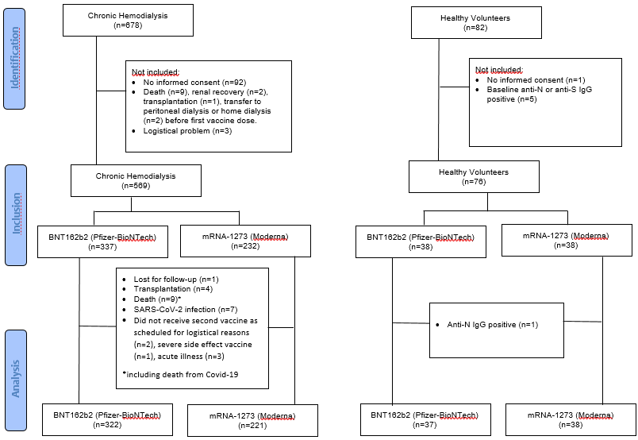

Supplemental Figure 2: Immune response by age category
Geometric mean titers (GMT) of the SARS-CoV-2 spike antibody (Panel A) and geometric mean concentration (GMC) of the QuantiFERON response to Antigen 2 (Panel B) at week 8/9 after BNT162b2 or mRNA-1273 vaccination in hemodialysis patients (red) and healthy volunteers (green) for the different age categories.
A
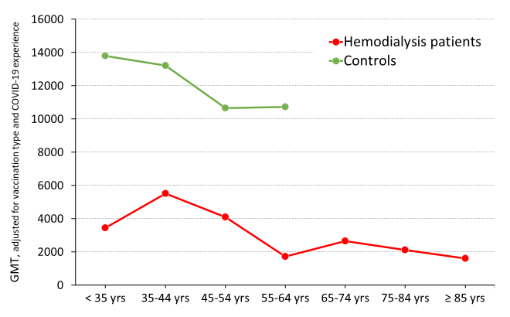
B
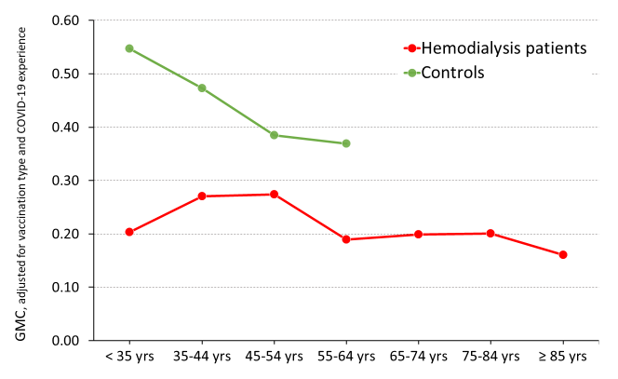

Supplemental Figure 3: Cellular response
Median (interquartile range) QuantiFERON response to Antigen 1 at week 4 and week 8 after BNT162b2 vaccination in hemodialysis patients (red dashed line) and healthy volunteers (red solid line) and at week 5 and week 9 after mRNA-1273 vaccination in hemodialysis patients (green dashed line) and healthy volunteers (green solid line).
